CS 547 Web Scripting

Assignment 3: jQuery enhanced Web Site – AztecA Book Publishing

Due Date: May 8th , 2015 5:30 pm PST

Points: 100

Description: Your Azteca Book Company website is getting popular and business is booming. Your publishers want to expand to greater audiences and markets. In particular they want to ensure that AztecA is an industry leader in the publishing world. They want their site to be cross platform compatible and have a rest API. If possible they would like to see a chart of the best sellers book list.

1. 50 Pts. Convert all form validation from server side code to client side code using jQuery. This includes email validation, but not checking if a new user exists in the database. That must be done on the server. For extra credit you can use an Ajax call to check if the user exists in the database.

2. 30 Pts. Create a rest API for exchanging information about the books for sale on your website. The information returned will be the same as what is displayed on your best seller’s page, but formatted for as a JSON object. This rest API may be queried with a HTTP GET verb. It will return the information on the best sellers page, but formatted as a JSON response. The rest URLs you must implement are

<http://YOURSITE/api/get_books?list=all>

This will return a JSON object containing all the books in your books page. If a book is not published it will not be displayed.

<http://YOURSITE/api/get_books?Top=10>

This will return a JSON object containing all the top 10 books on your books page. If the number of books is 0 it will return an empty object. If the number top is less that the number of books in your system, return the number of books you have e.g. they request Top=100 and you have 9 records, then you should return a JSON object with 9 book objects in it. You may use any of the programming languages and tools to implement this part.

3. 25 Pts Extra Credit. Create a get book info rest endpoint. If a user gets the ID of a best selling book from the endpoints above, then they can get the info about that one book with

<http://YOURSITE/api/get_book?ID=12>

4.25 Pts Extra Extra Credit. Secure your API with a private key. If the rest endpoint is not queried with the correct private key, then the service returns an error message and an empty JSON object. Note to fully secure the rest endpoint you will have to use a POST instead of a get.

5 20 Pts. using a jQuery plugin-in such as high Charts, create a plot of the number of books sold on your best seller page.

Other notes: It is expected that this assignment will be added to your website from assignment 1 and 2.

Turning in your assignment

We will be using blackboard to turn in the assignment. Your files will be zipped up as a zip formatted archive and uploaded to your blackboard account.

Further details will be announced on the website. This assignment will be amended.

Examples of the Rest API:

My best seller page looks like;

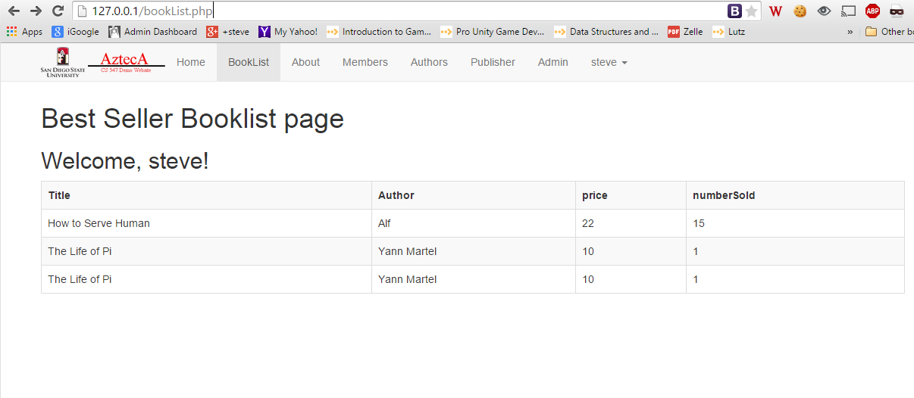

Calling <http://127.0.0.1/api/get_books.php> yeilds

**decoded json**

Array ( [0] => stdClass Object ( [book_id] => 4 [title] => How to Serve Human [author] => Alf [price] => 22 [isPublished] => 1 [numberSold] => 15 ) [1] => stdClass Object ( [book_id] => 1 [title] => The Life of Pi [author] => Yann Martel [price] => 10 [isPublished] => 1 [numberSold] => 1 ) [2] => stdClass Object ( [book_id] => 2 [title] => The Life of Pi [author] => Yann Martel [price] => 10 [isPublished] => 1 [numberSold] => 1 ) )

**raw json**

[{"book_id":"4","title":"How to Serve Human","author":"Alf","price":"22","isPublished":"1","numberSold":"15"},{"book_id":"1","title":"The Life of Pi","author":"Yann Martel","price":"10","isPublished":"1","numberSold":"1"},{"book_id":"2","title":"The Life of Pi","author":"Yann Martel","price":"10","isPublished":"1","numberSold":"1"}]